Test Case: tc002_SPX_Dev5_Crear_Requisicion_Spot_Con_FAD_Tipo_Cobro_CC
Step 1 - Enter username and password and click to button Enter : Credentials Entered
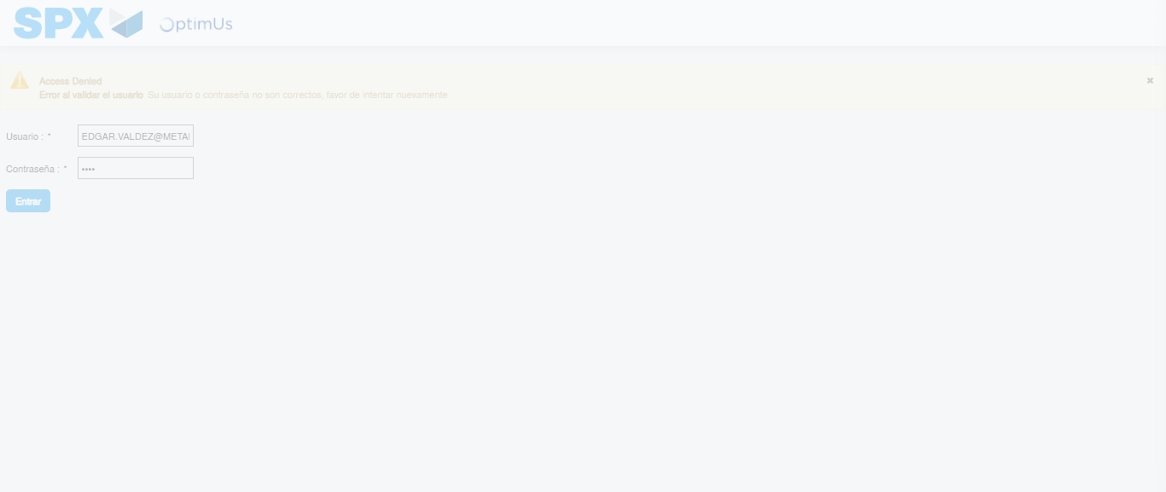Image file-name: QC_Testing-tc002_SPX_Dev5_Crear_Requisicion_Spot_Con_FAD_Tipo_Cobro_CC-1781656561888

Step 2 - Select to UEN and Access to Spot Buy Requisitions : UEN Correctly selected and Correct access
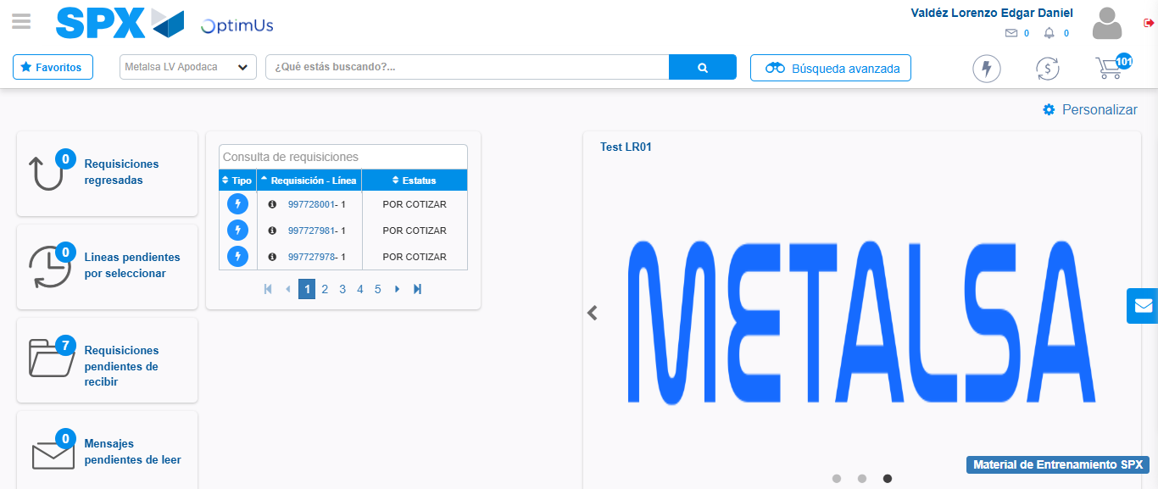Image file-name: QC_Testing-tc002_SPX_Dev5_Crear_Requisicion_Spot_Con_FAD_Tipo_Cobro_CC-1781656587538

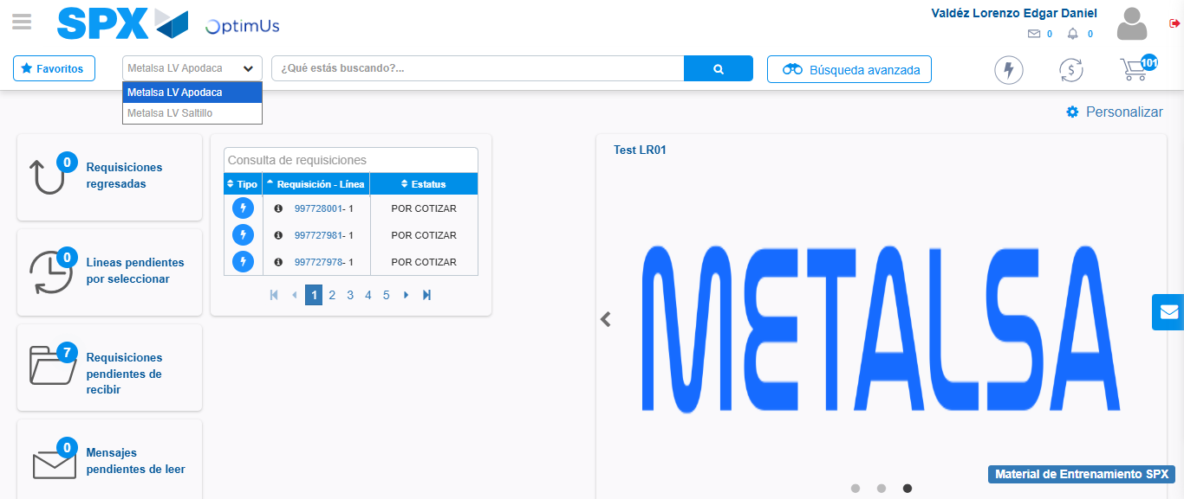Image file-name: QC_Testing-tc002_SPX_Dev5_Crear_Requisicion_Spot_Con_FAD_Tipo_Cobro_CC-1781656590119

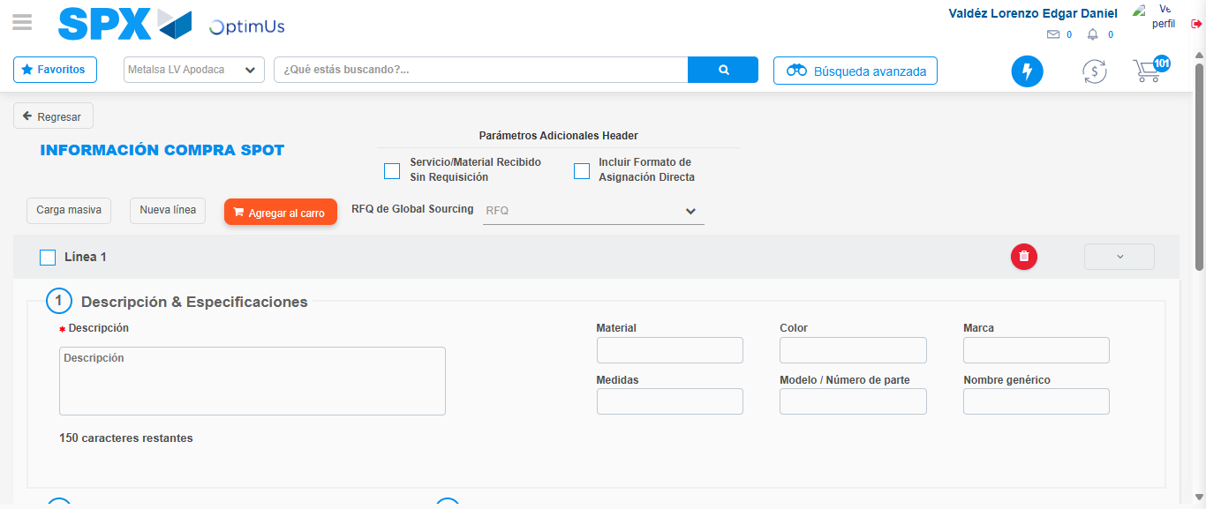Image file-name: QC_Testing-tc002_SPX_Dev5_Crear_Requisicion_Spot_Con_FAD_Tipo_Cobro_CC-1781656616888

Step 3 - Add FAD to Requisition: FAD Successfully Added
Image file-name: QC_Testing-tc002_SPX_Dev5_Crear_Requisicion_Spot_Con_FAD_Tipo_Cobro_CC-1781656617129

Image file-name: QC_Testing-tc002_SPX_Dev5_Crear_Requisicion_Spot_Con_FAD_Tipo_Cobro_CC-1781656617328

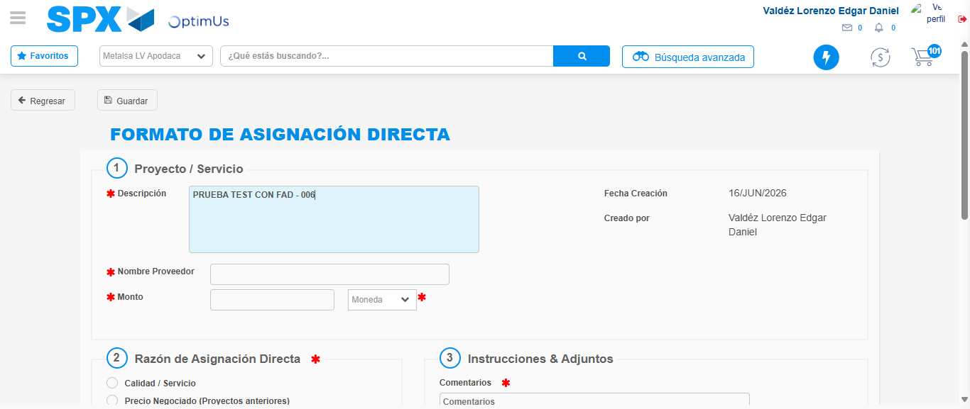Image file-name: QC_Testing-tc002_SPX_Dev5_Crear_Requisicion_Spot_Con_FAD_Tipo_Cobro_CC-1781656620044

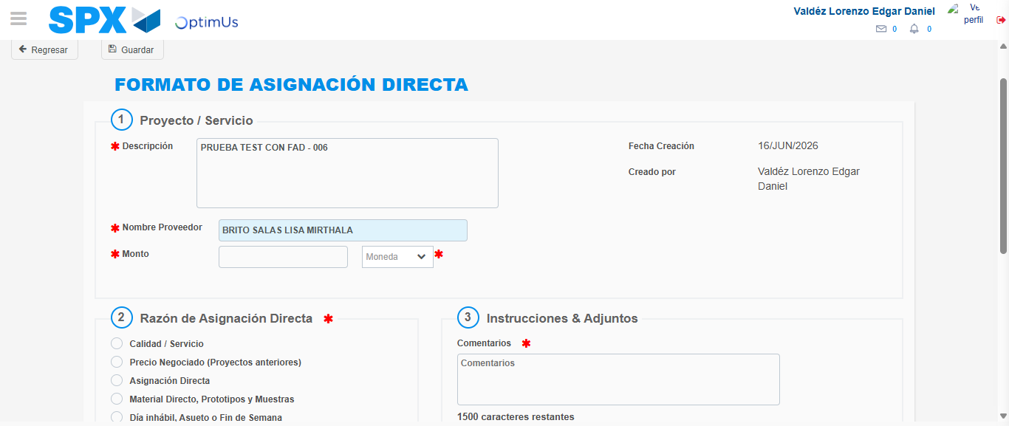Image file-name: QC_Testing-tc002_SPX_Dev5_Crear_Requisicion_Spot_Con_FAD_Tipo_Cobro_CC-1781656624917

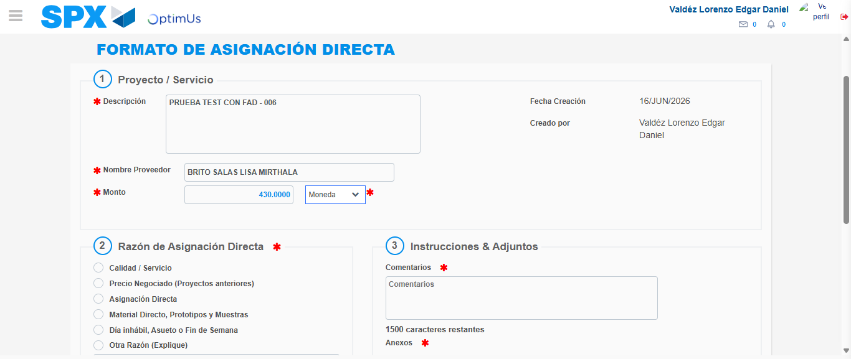Image file-name: QC_Testing-tc002_SPX_Dev5_Crear_Requisicion_Spot_Con_FAD_Tipo_Cobro_CC-1781656625339

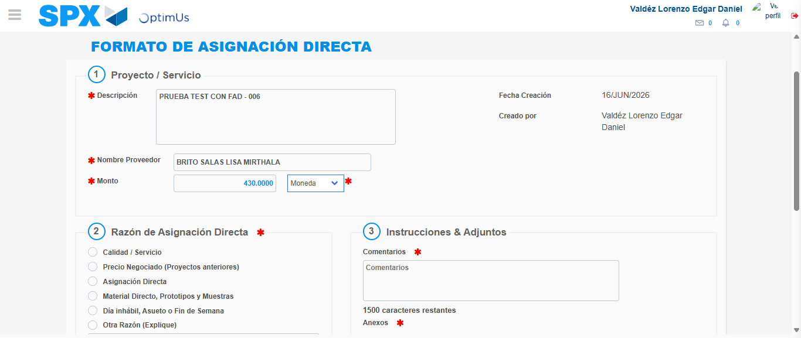Image file-name: QC_Testing-tc002_SPX_Dev5_Crear_Requisicion_Spot_Con_FAD_Tipo_Cobro_CC-1781656625561

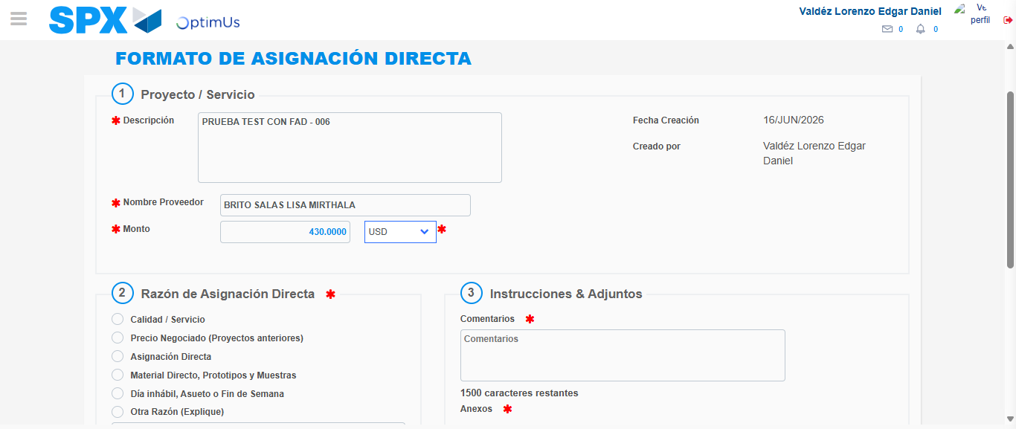Image file-name: QC_Testing-tc002_SPX_Dev5_Crear_Requisicion_Spot_Con_FAD_Tipo_Cobro_CC-1781656625882

Image file-name: QC_Testing-tc002_SPX_Dev5_Crear_Requisicion_Spot_Con_FAD_Tipo_Cobro_CC-1781656626059

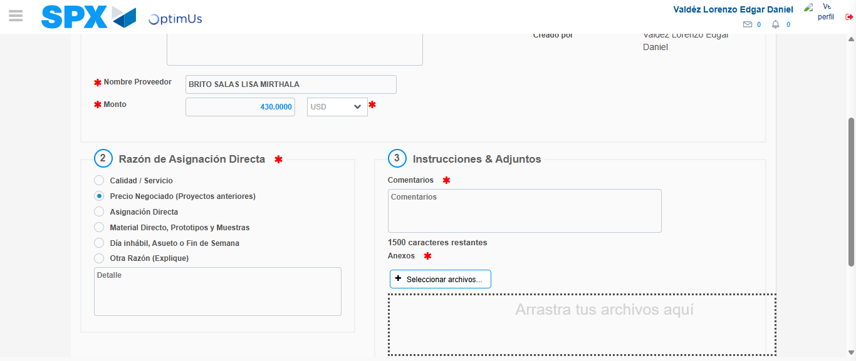Image file-name: QC_Testing-tc002_SPX_Dev5_Crear_Requisicion_Spot_Con_FAD_Tipo_Cobro_CC-1781656626856

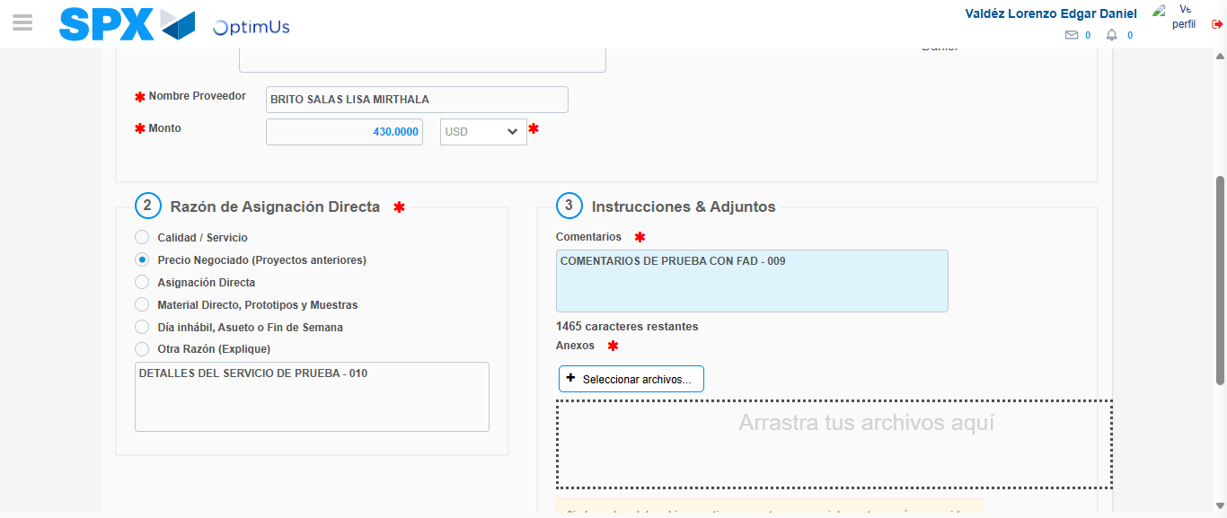Image file-name: QC_Testing-tc002_SPX_Dev5_Crear_Requisicion_Spot_Con_FAD_Tipo_Cobro_CC-1781656637694

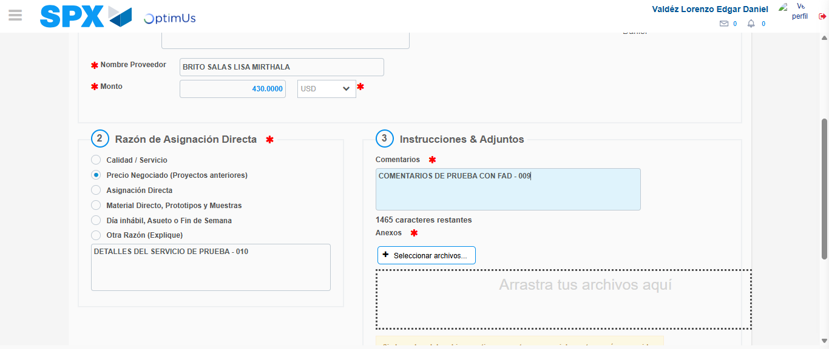Image file-name: QC_Testing-tc002_SPX_Dev5_Crear_Requisicion_Spot_Con_FAD_Tipo_Cobro_CC-1781656638328

Step 4 - Data Capture Spot Buy Requisition: Data captured correctly
Image file-name: QC_Testing-tc002_SPX_Dev5_Crear_Requisicion_Spot_Con_FAD_Tipo_Cobro_CC-1781656617129

Image file-name: QC_Testing-tc002_SPX_Dev5_Crear_Requisicion_Spot_Con_FAD_Tipo_Cobro_CC-1781656617328

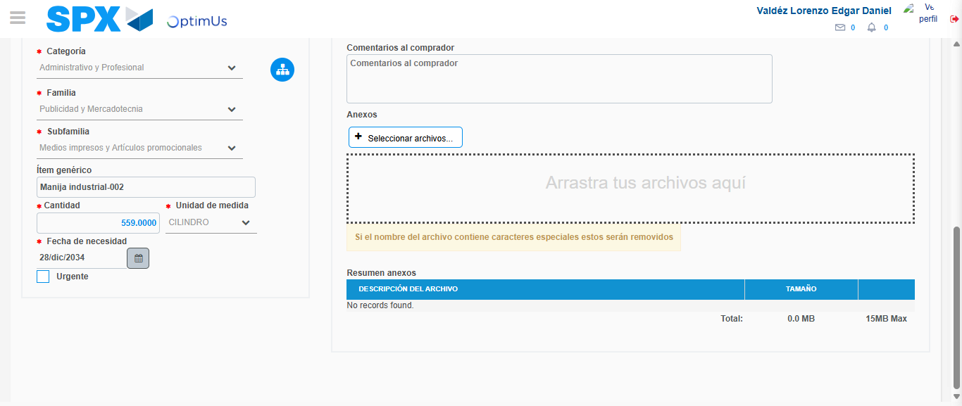Image file-name: QC_Testing-tc002_SPX_Dev5_Crear_Requisicion_Spot_Con_FAD_Tipo_Cobro_CC-1781656654832

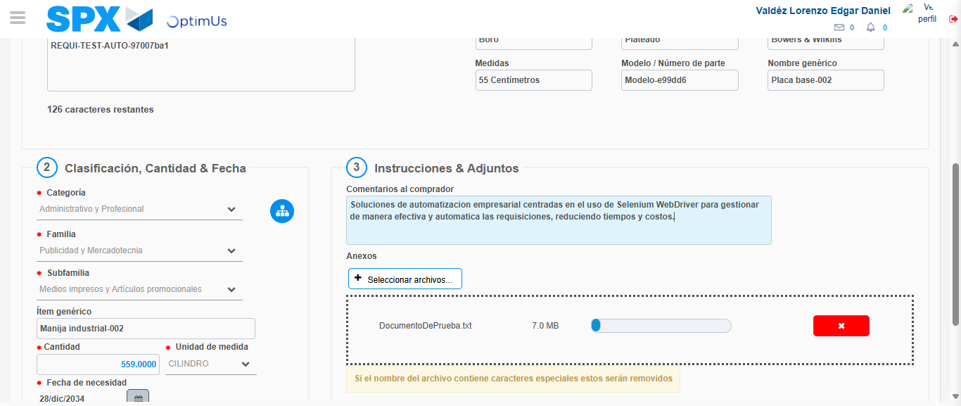Image file-name: QC_Testing-tc002_SPX_Dev5_Crear_Requisicion_Spot_Con_FAD_Tipo_Cobro_CC-1781656655634

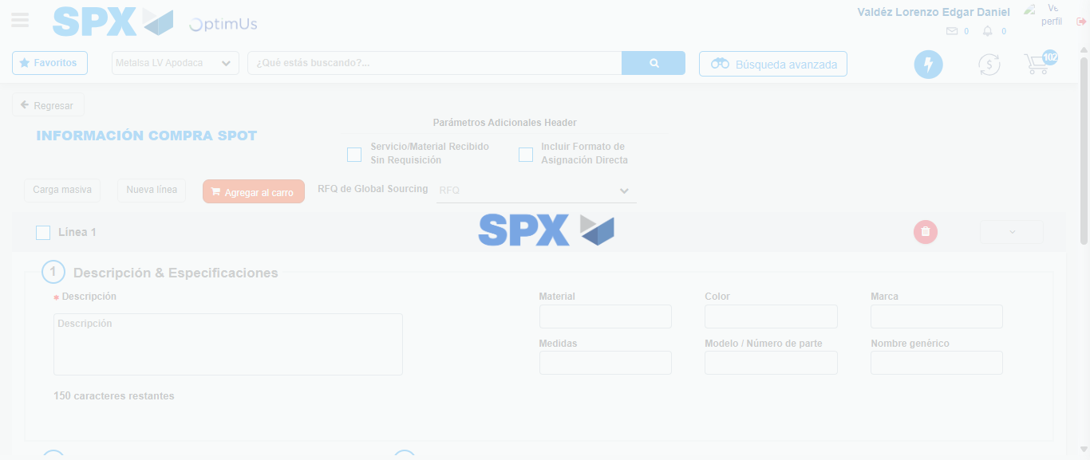Image file-name: QC_Testing-tc002_SPX_Dev5_Crear_Requisicion_Spot_Con_FAD_Tipo_Cobro_CC-1781656660793

Step 5 - Select to Requisition: Requisition Correctly selected
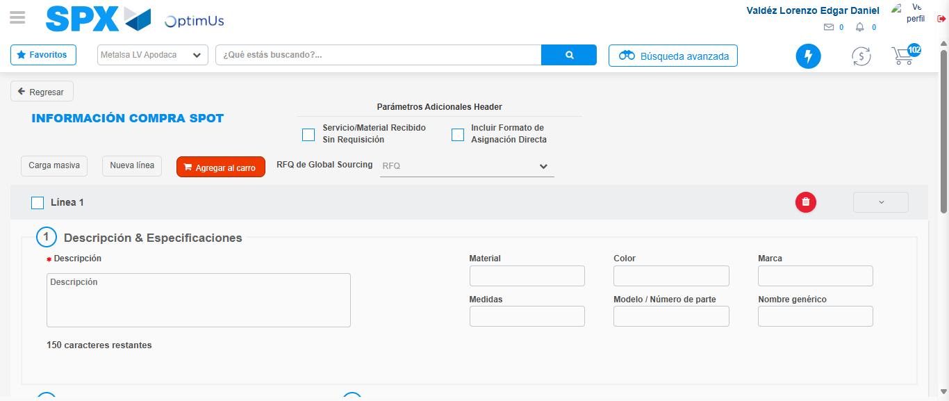Image file-name: QC_Testing-tc002_SPX_Dev5_Crear_Requisicion_Spot_Con_FAD_Tipo_Cobro_CC-1781656660998

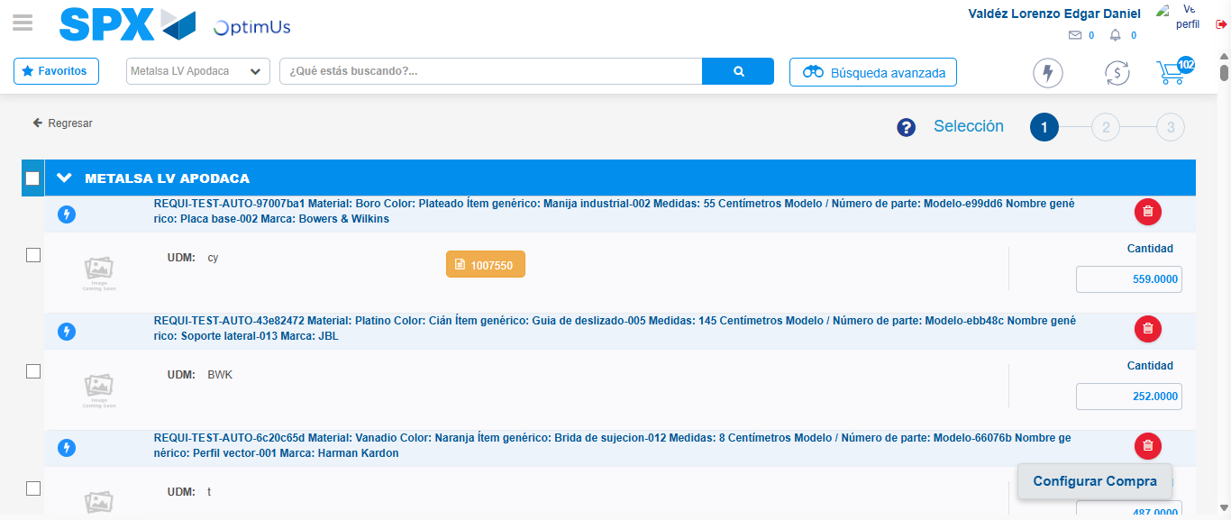Image file-name: QC_Testing-tc002_SPX_Dev5_Crear_Requisicion_Spot_Con_FAD_Tipo_Cobro_CC-1781656668972

Image file-name: QC_Testing-tc002_SPX_Dev5_Crear_Requisicion_Spot_Con_FAD_Tipo_Cobro_CC-1781656669212

Image file-name: QC_Testing-tc002_SPX_Dev5_Crear_Requisicion_Spot_Con_FAD_Tipo_Cobro_CC-1781656669398

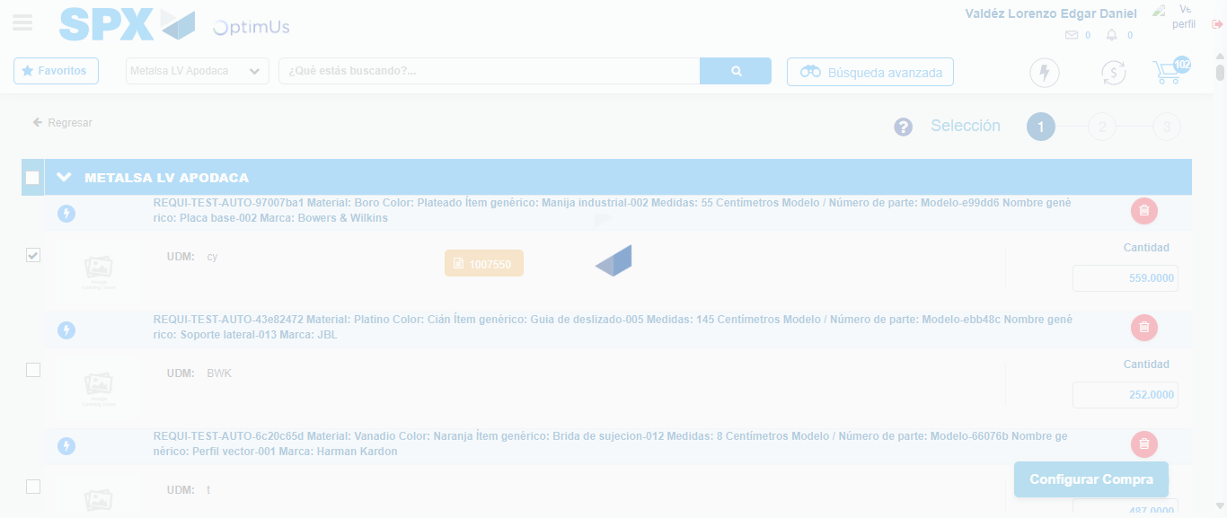Image file-name: QC_Testing-tc002_SPX_Dev5_Crear_Requisicion_Spot_Con_FAD_Tipo_Cobro_CC-1781656670306

Step 6 - Select Type Account For Requisition: Type Account Correctly selected
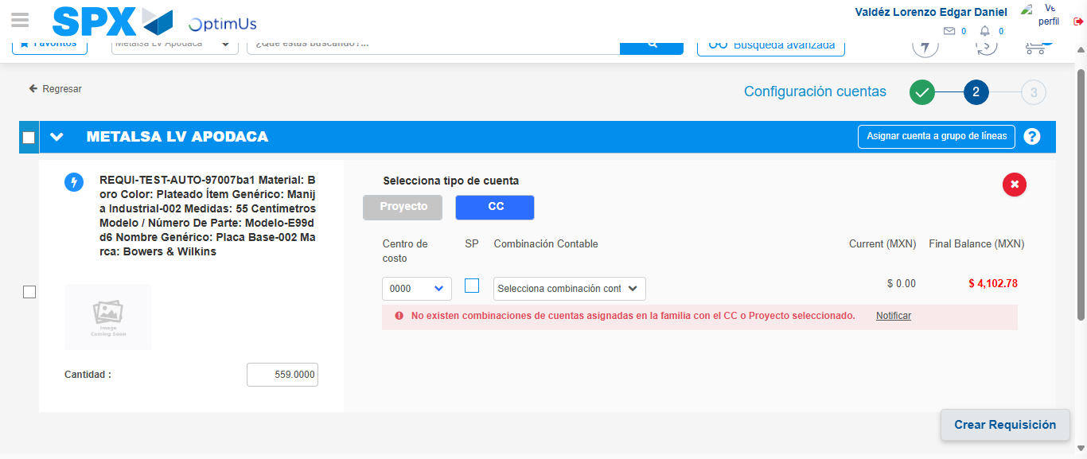Image file-name: QC_Testing-tc002_SPX_Dev5_Crear_Requisicion_Spot_Con_FAD_Tipo_Cobro_CC-1781656711394

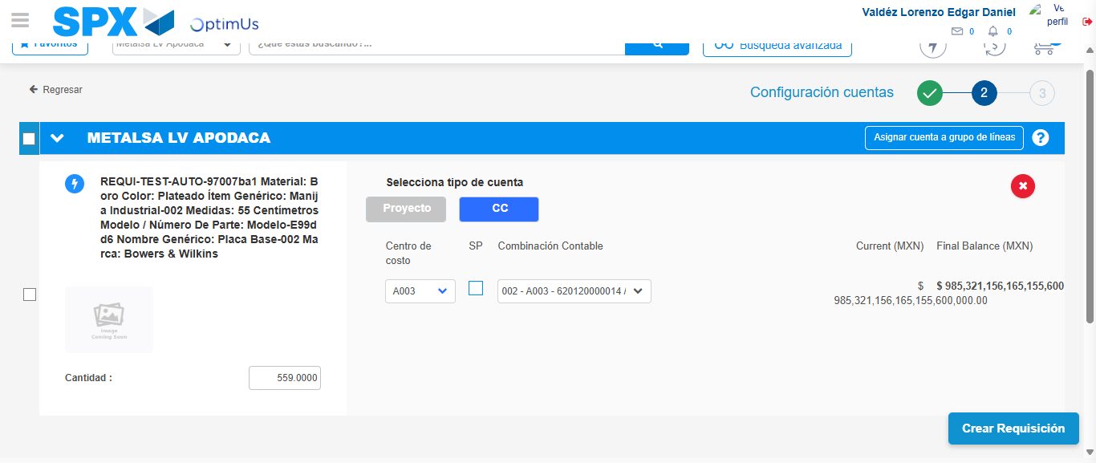Image file-name: QC_Testing-tc002_SPX_Dev5_Crear_Requisicion_Spot_Con_FAD_Tipo_Cobro_CC-1781656719394

Image file-name: QC_Testing-tc002_SPX_Dev5_Crear_Requisicion_Spot_Con_FAD_Tipo_Cobro_CC-1781656719607

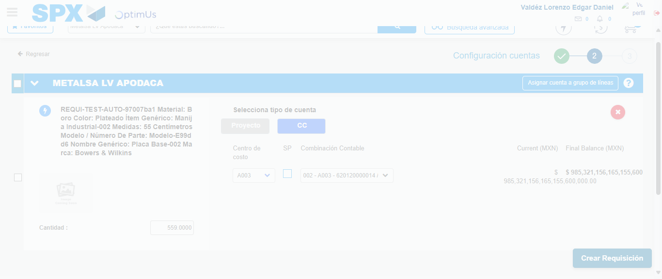Image file-name: QC_Testing-tc002_SPX_Dev5_Crear_Requisicion_Spot_Con_FAD_Tipo_Cobro_CC-1781656720015

Step 7 - Accept to Requisition: Requisition Accepted
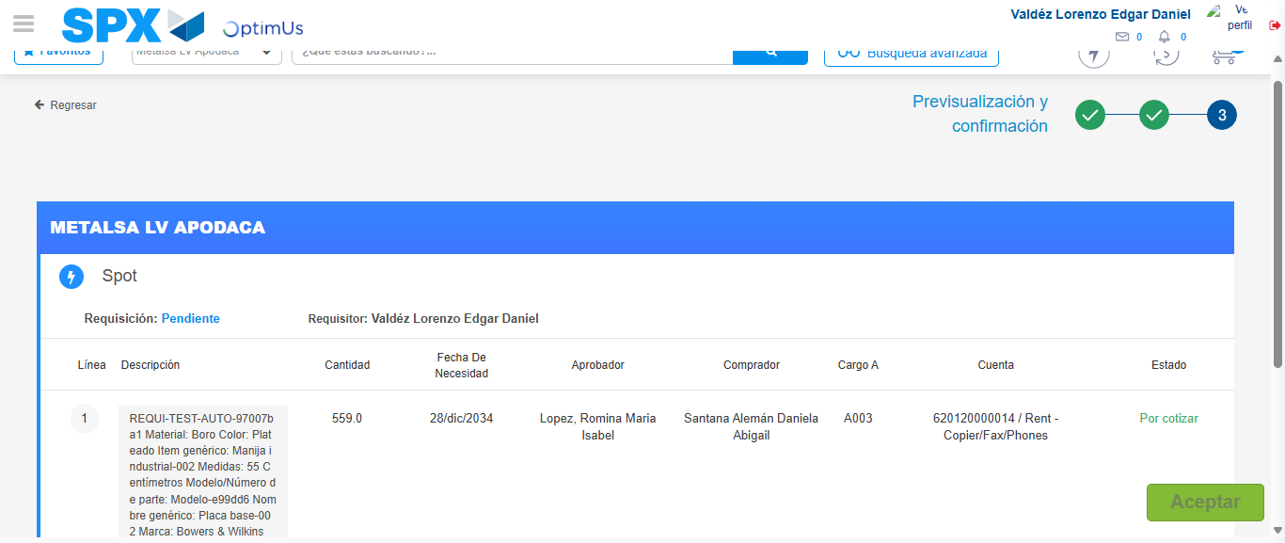Image file-name: QC_Testing-tc002_SPX_Dev5_Crear_Requisicion_Spot_Con_FAD_Tipo_Cobro_CC-1781656720859

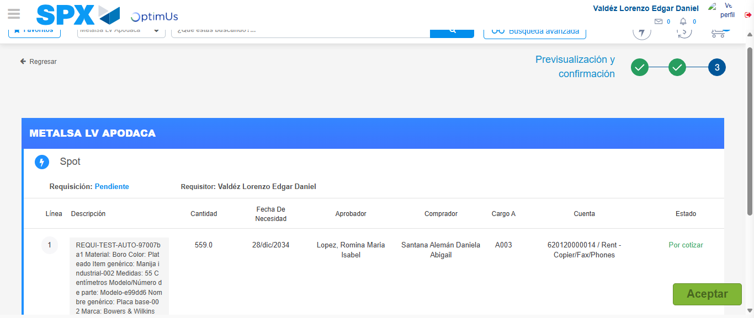Image file-name: QC_Testing-tc002_SPX_Dev5_Crear_Requisicion_Spot_Con_FAD_Tipo_Cobro_CC-1781656721089

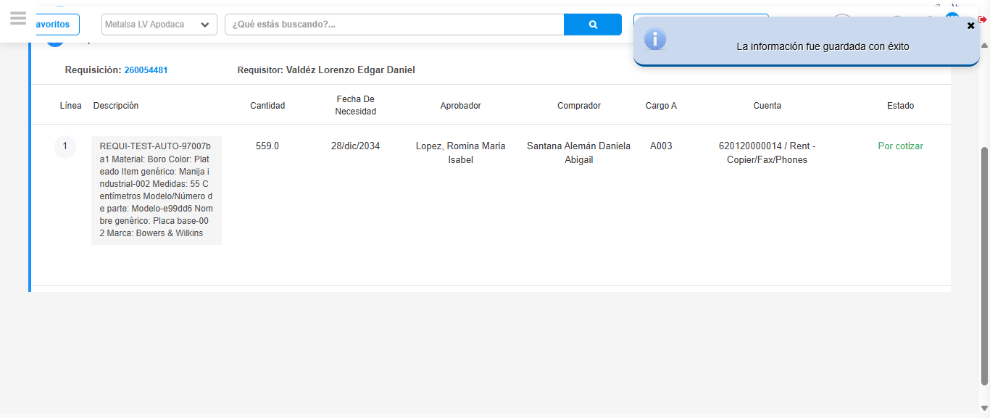Image file-name: QC_Testing-tc002_SPX_Dev5_Crear_Requisicion_Spot_Con_FAD_Tipo_Cobro_CC-1781656724593

Step 8 - Return to Main Page SPX : Return to Main Page SPX
Image file-name: QC_Testing-tc002_SPX_Dev5_Crear_Requisicion_Spot_Con_FAD_Tipo_Cobro_CC-1781656587538

Image file-name: QC_Testing-tc002_SPX_Dev5_Crear_Requisicion_Spot_Con_FAD_Tipo_Cobro_CC-1781656590119

Image file-name: QC_Testing-tc002_SPX_Dev5_Crear_Requisicion_Spot_Con_FAD_Tipo_Cobro_CC-1781656616888

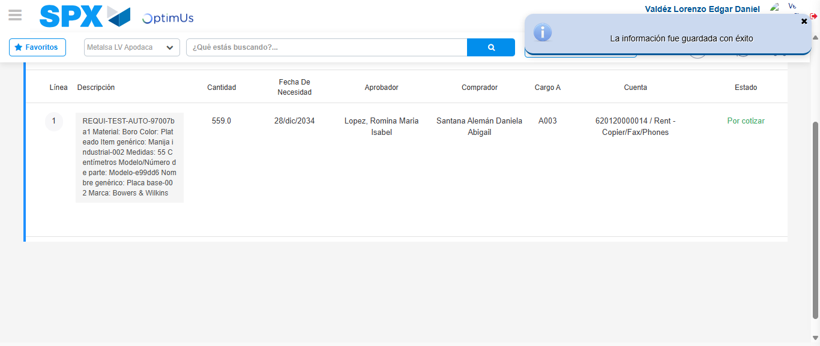Image file-name: QC_Testing-tc002_SPX_Dev5_Crear_Requisicion_Spot_Con_FAD_Tipo_Cobro_CC-1781656726800

Image file-name: QC_Testing-tc002_SPX_Dev5_Crear_Requisicion_Spot_Con_FAD_Tipo_Cobro_CC-1781656726959

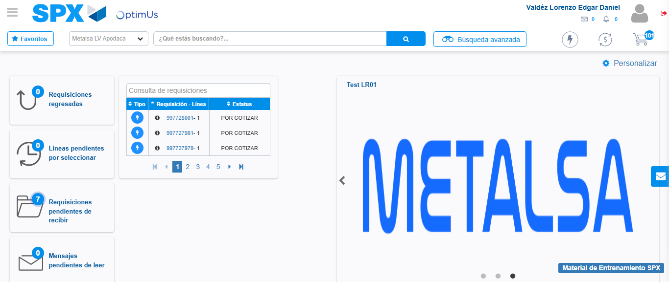Image file-name: QC_Testing-tc002_SPX_Dev5_Crear_Requisicion_Spot_Con_FAD_Tipo_Cobro_CC-1781656748083

Step 9 - Log Out : Log Out SPX
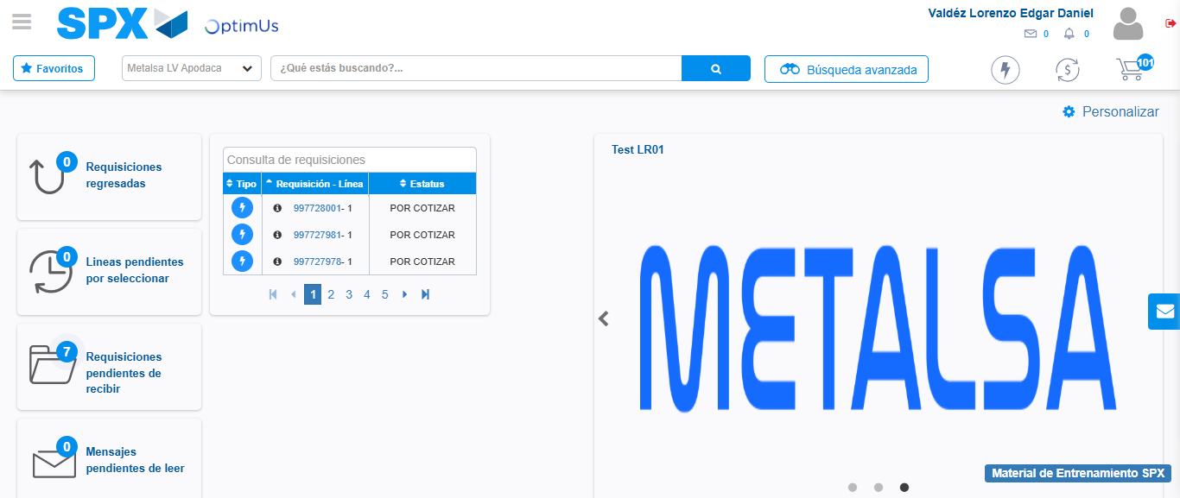Image file-name: QC_Testing-tc002_SPX_Dev5_Crear_Requisicion_Spot_Con_FAD_Tipo_Cobro_CC-1781656748340

